Specially abled (Deaf and Dump) people who is not able to hear or speak anything.

Specially abled persons often have lower education accomplishments, poorer health conditions, higher poverty rates and less economic engagement then people without disabilities.

A person with a hearing impairment may wish to use a closed FM amplification system or sign language interpreter when participating in group activities. Use drawings, writing, and gestures to assist you in communicating.

f

We as a society must help specially abled people to focus on their strengths, instead of their weaknesses so that they can enjoy their life like us. We should also accept them as equal and not someone who need to be pitied.

1. The lack of accessibility in national sign languages
2. The lack of awareness and training for healthcare professionals and
3. The barriers related to the pandemic.

Provide guidance and counselling to differently abled individuals. Create awareness about the needs of differently abled persons, and other general issues concerning their learning.

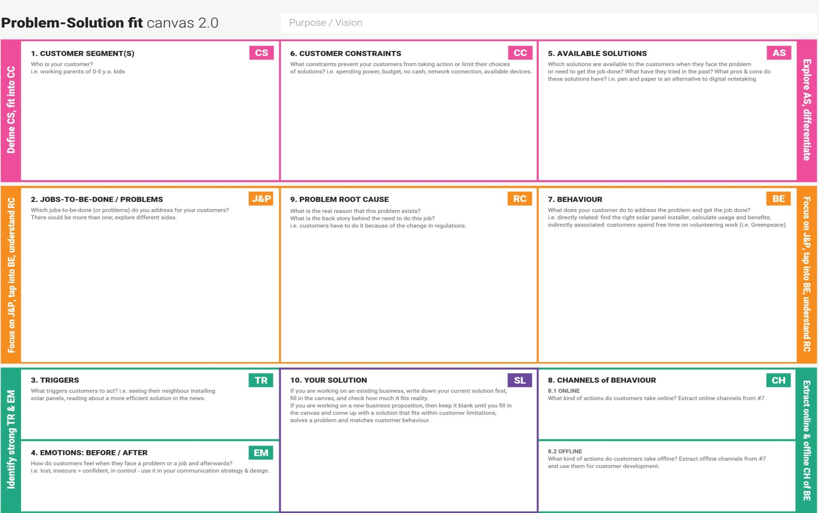

Hearing loss can affect a person in three main ways: **fewer educational and job opportunities due to impaired communication**. social withdrawal due to reduced access to services and difficulties communicating with others. emotional problems caused by a drop in self- esteem and confidence.

The differently abled people communicate with each other by **mere gestures, physical touch, finger sensations and stimulations on the skin of the sufferer and a multitude of techniques that did not find its existence on the grounds of technicality**

Differently-abled people face discrimination in everyday life. People suffering from mental illness or mental retardation face the worst stigma and are subject to severe social exclusion.

The project aims to develop a system that converts the sign language into a human hearing voice or text in the desired language to convey a message to normal people, as well as convert speech or text into understandable sign language for the deaf and dumb.

The use of technology in special education **helps break the barriers for people with disabilities and provide them with access to the most relevant educational programs**.